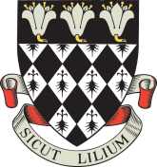

Magdalen College School

Application Form for 13+ Art Scholarship 2021 (internal)

Portfolios to be submitted on Wednesday 3rd March 2021 by 8.30am
Interviews: Friday 12th March 2021

To the Registrar, Magdalen College School

I would like my son: ………...………………………………………………………………

House /Form: ………...………………………………………………………………

to be considered for the award of an Art Scholarship.

He will submit his portfolio to the Head of Art by 8.30am on Wednesday 3rd March 2021, and, if invited, will attend an interview on Friday 12th March 2021.

Signed ………………………………………………………………………………………….

Date ………………………………………………………………………………………….

Closing date for return of form: Friday 8th January 2021

