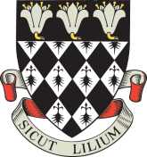

Magdalen College School

Application Form for 13+ Art Scholarship 2020

Portfolios to be submitted on Wednesday 3rd March 2021 by 8.30am
Interviews: Friday 12th March 2021

Boy’s Name in Full ................................................................................................................................

Date of Birth ................................................................................................................................

Parents ................................................................................................................................

Address ................................................................................................................................

................................................................................................................................

................................................................................................................................

Telephone Number ................................................................................................................................

Current School ................................................................................................................................

Candidates for an Art Scholarship must be registered for entry to Magdalen College School.

This form should be accompanied by a letter of recommendation from the candidate’s Head of Art and should be returned by Friday 8th January 2021 to:

The Registrar, Magdalen College School, Oxford OX4 1DZ
registrar@mcsoxford.org

