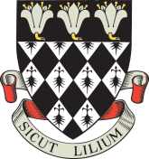

Magdalen College School

Application Form for Sixth Form Art Scholarship 2020

Application deadline: Monday 4th November 2019
Portfolio to be submitted: Friday 29th November 2019, by 8.30am
Assessment: Friday 6th December 2019

Pupil’s Name in Full ................................................................................................................................

Date of Birth ................................................................................................................................

Parents ................................................................................................................................

Address ................................................................................................................................

................................................................................................................................
................................................................................................................................

Telephone Number ................................................................................................................................

Current School ................................................................................................................................

Candidates for an Art Scholarship must be registered for entry to Magdalen College School.

This form should be accompanied by a letter of recommendation from the candidate’s Head of Art and should be returned by Monday 4th November 2019 to:

The Registrar, Magdalen College School, Oxford OX4 1DZ
registrar@mcsoxford.org

