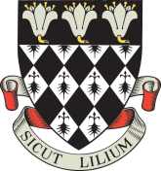

Magdalen College School

Application Form for 13+ Art Scholarship 2020 (internal)

Portfolios to be submitted on Wednesday 4th March 2010 by 8.30am
Interviews: Friday 13th March 2020

To the Registrar, Magdalen College School

I would like my son: ………...………………………………………………………………

House ………...………………………………………………………………

to be considered for the award of an Art Scholarship.

He will submit his portfolio to the Head of Art by 8.30am on Wednesday 4th March 2020, and, if invited, will attend an interview on Friday 13th March 2020.

Signed ………………………………………………………………………………………….

Date ………………………………………………………………………………………….

Closing date for return of form: Friday 10th January 2020

